**Accredited by NAAC with B++** and **ISO 9001:2015 Certified Institute**

**Sant Gajanan Maharaj College of Engineering, Mahagaon**

**Department of Electronics & Telecommunication Engineering Project Work Diary**

**Academic Year:** 2023-24 **Semester:** VII/VIII

**Title of Project: "Automatic Irrigation and Fertilization system to the root zone of plants”**

**Name of Students:**

|  |  |  |  |
| --- | --- | --- | --- |
| **Roll No** | **Name of Students** | **Ph. No.** | **Email ID** |
| 01 | Mr. Roshan Ashok Avdan | 8530408749 | awadanroshan01@gmail.com |
| 04 | Mr. Bharat Laxman Gawade | 7350239109 | bgavade418agmail.com |
| 10 | Mr. Abhishek Dattatray Kole | 9960837964 | koleabhishek2002@gmail.com |

**Student Photographs**

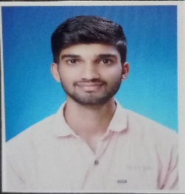 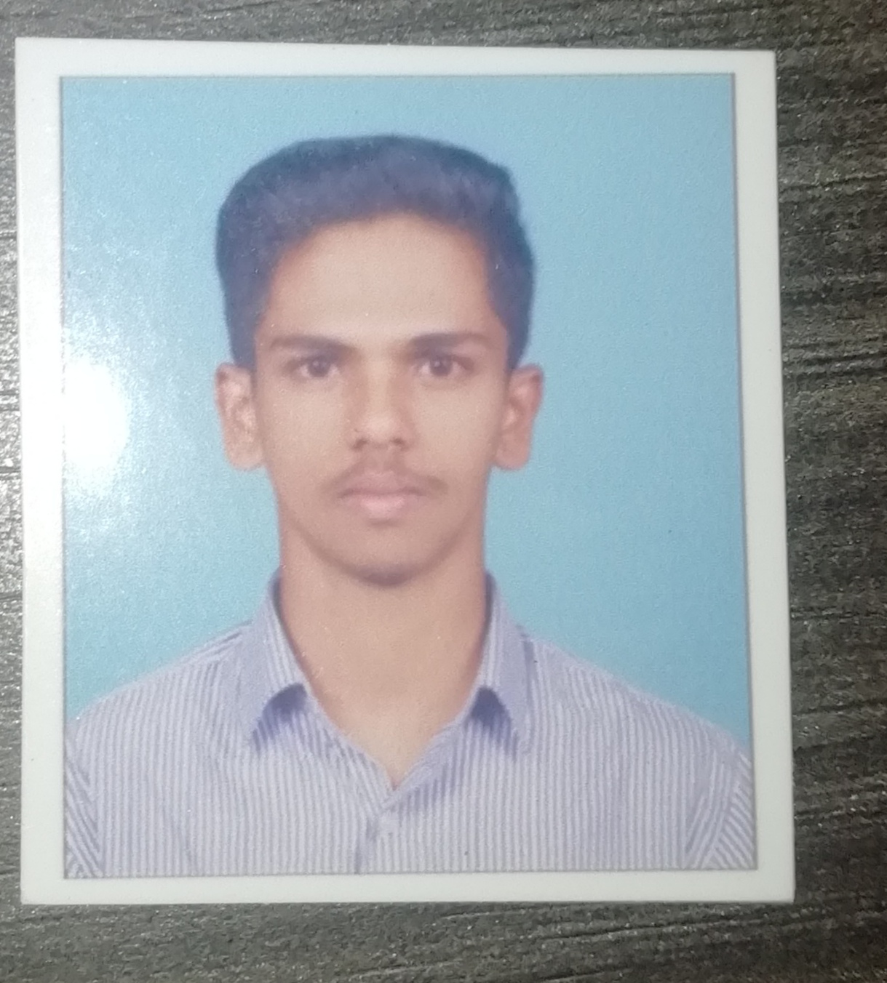 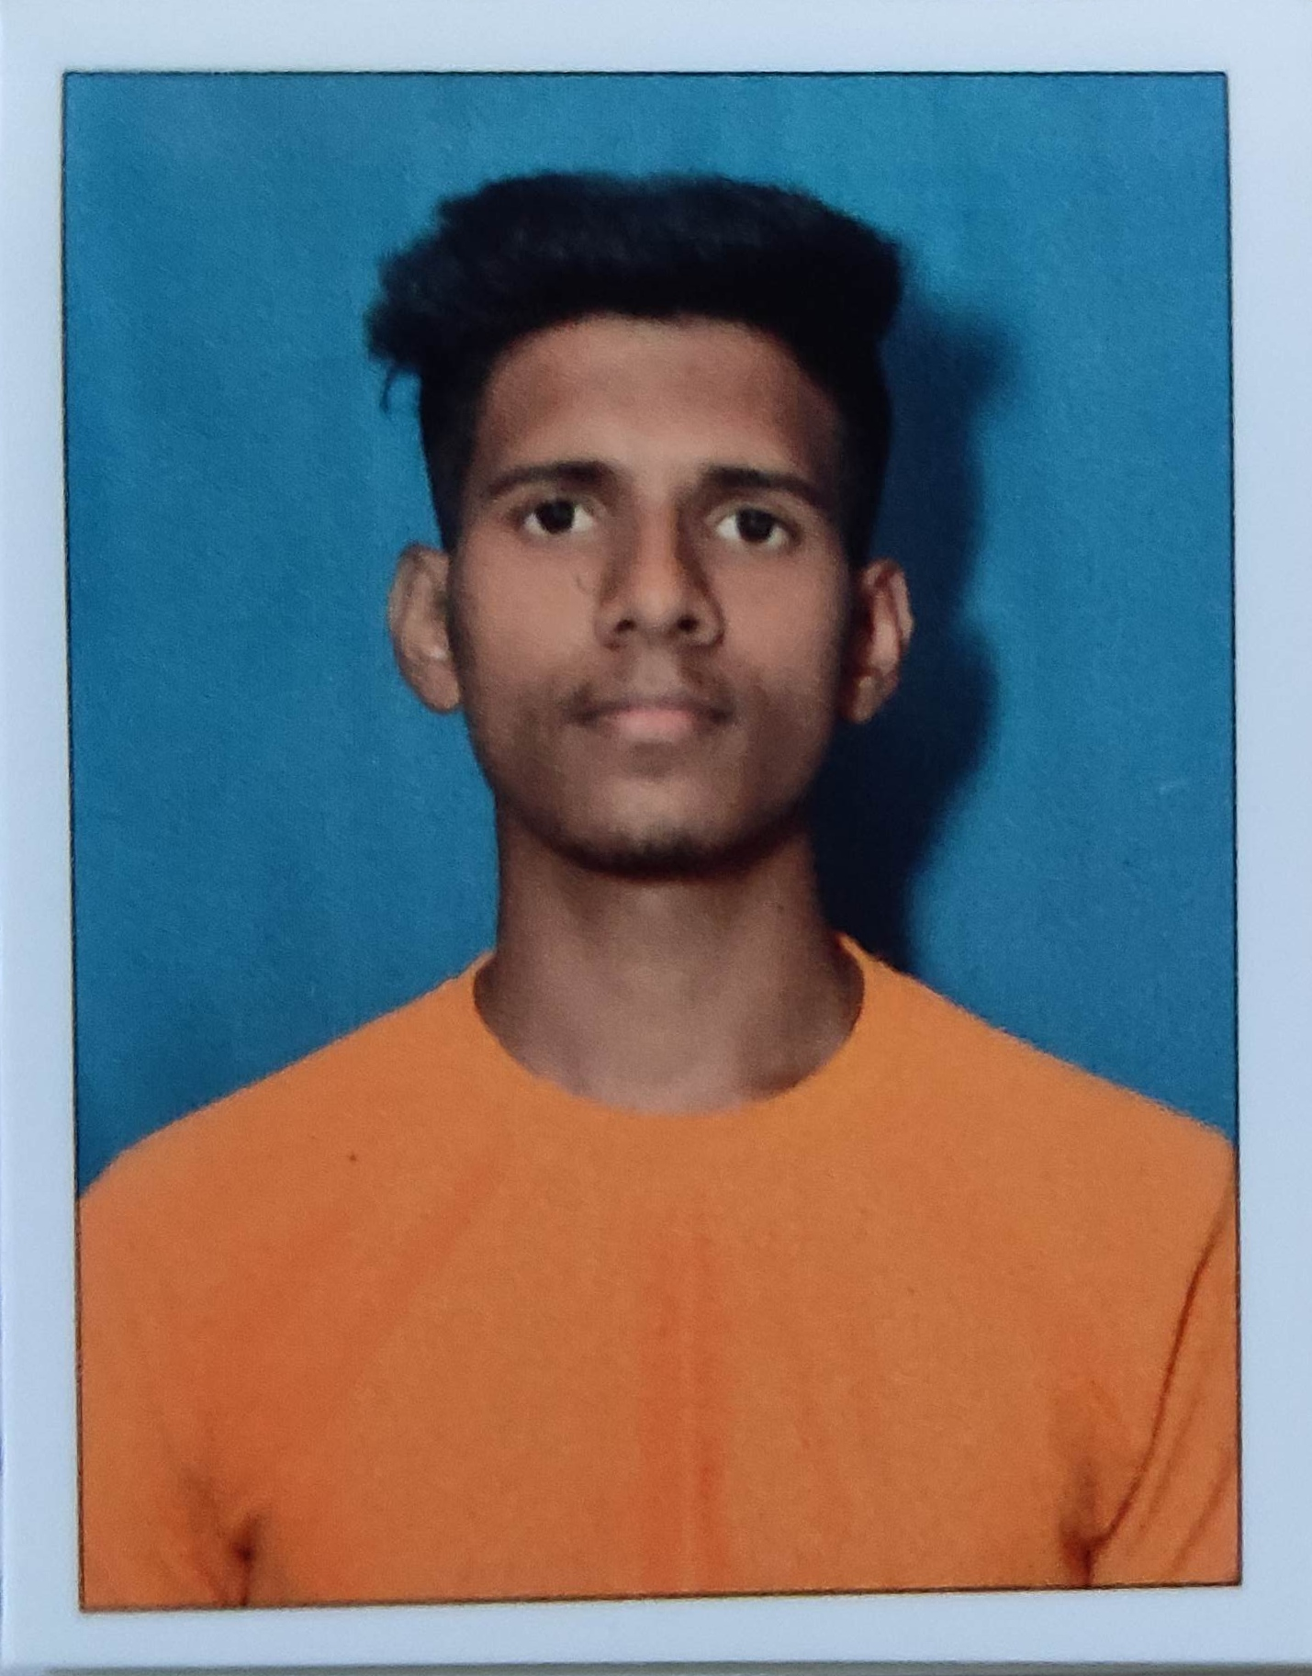

**(Mr. Roshan A. Avadan) (Mr. Bharat L. Gawade) (Mr. Abhishek D. Kole)**

**Name of the Guide: Prof. S. T. Matale** **Co-Ordinator: Prof. V. K. Salunkhe Name** **of the HOD: Prof. A. B. Farakte**

**Project Photo with Guide & Students:**

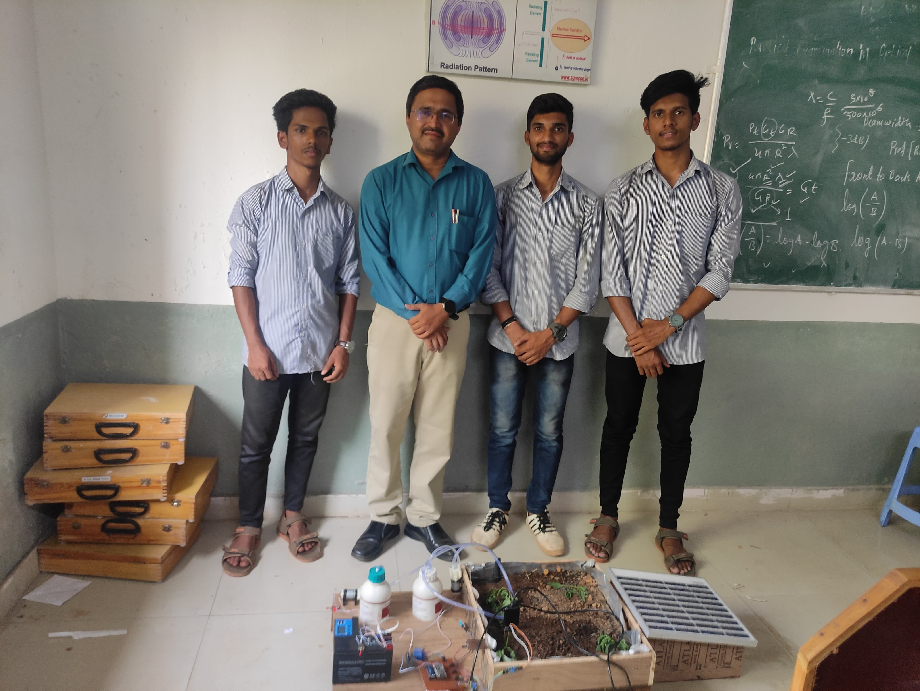

**Sign of Guide Sign of H.O.D**

**CONCEPTUAL DESIGN OF THE PROJECT**

**Block Diagram**

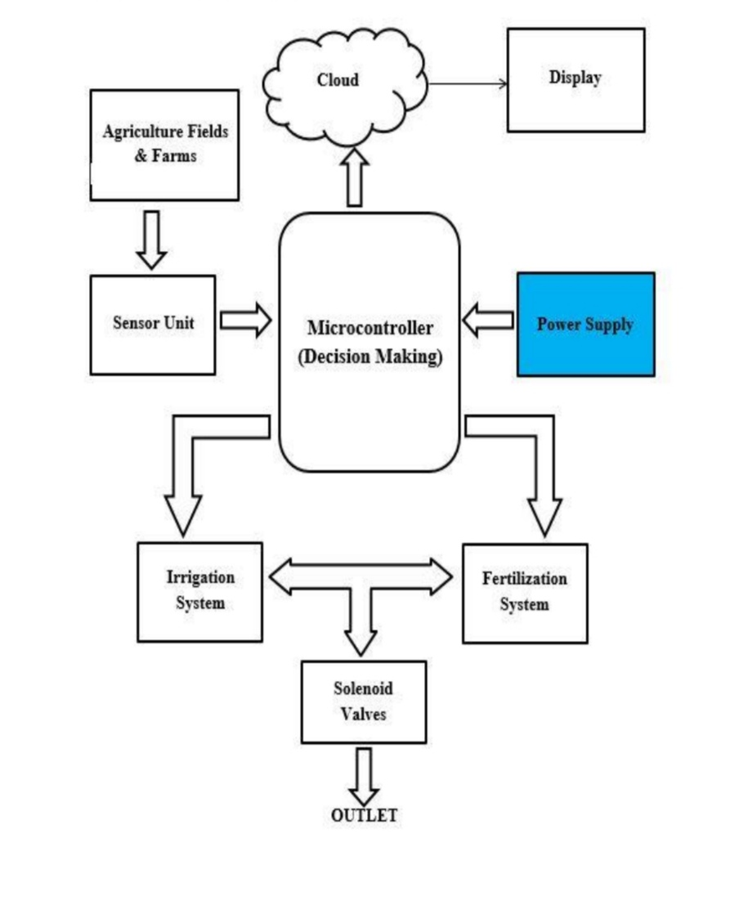

**Fig no.1 Block diagram of Irrigation and Fertilization System.**

**Circuit Diagram:**

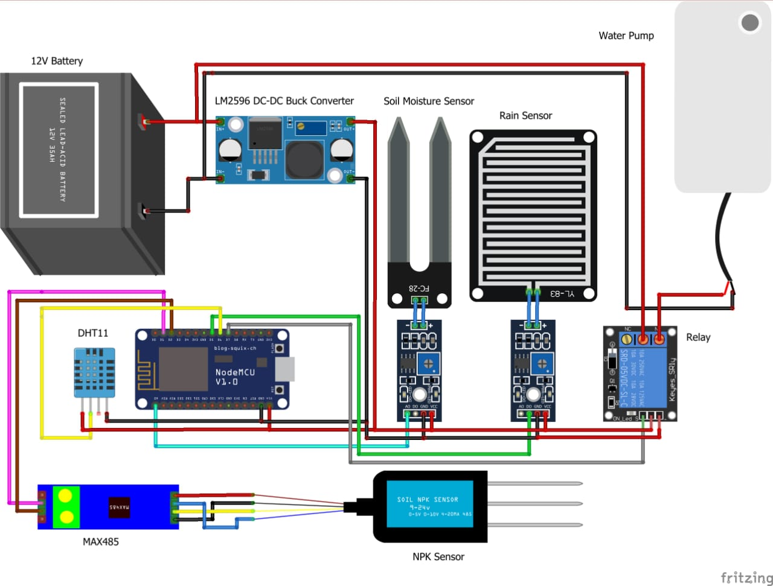

**Fig no.2 Circuit diagram of irrigation and fertilization system.**

**Flow Chart of the Project:**

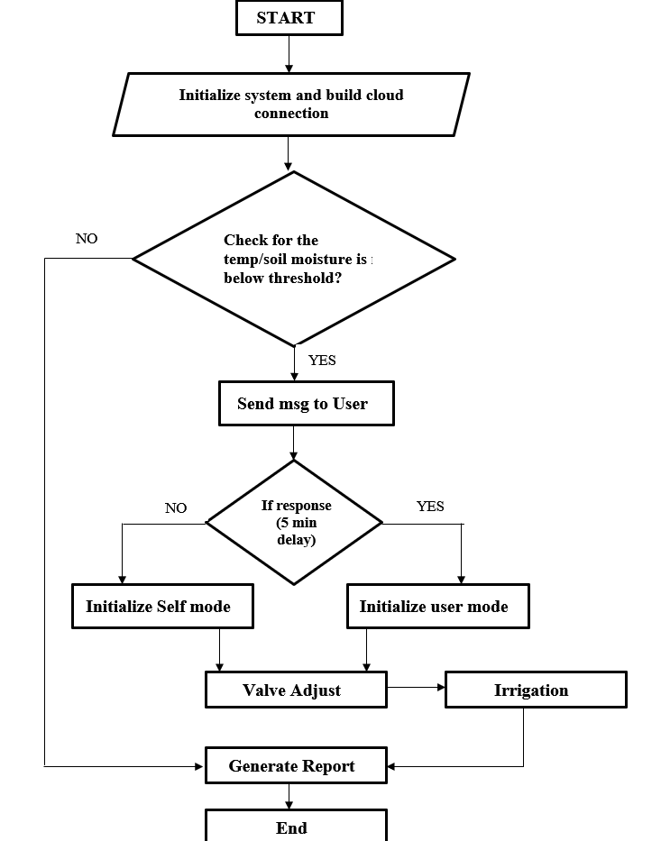

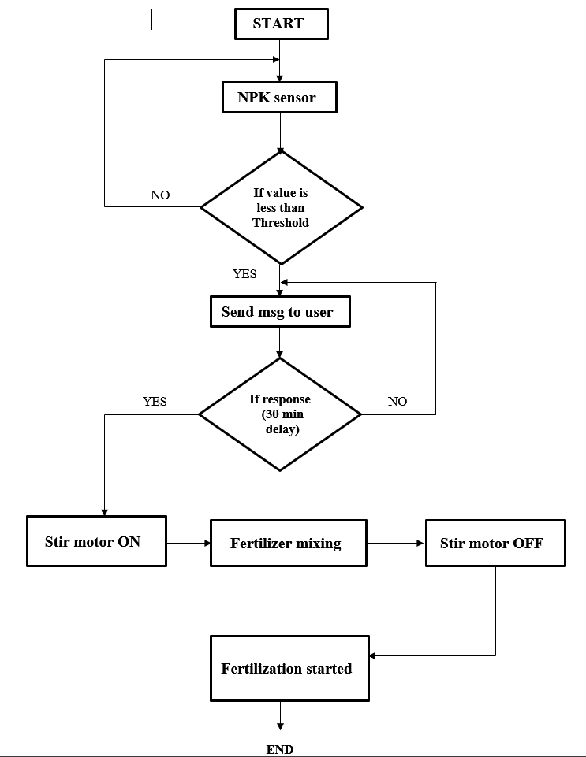

**Fig no. 3 flow chart of irrigation system Fig no. 4 flow chart of fertilization system**

**WEEKLY PROJECT PROGRESS REPORT**

* **Date: 2 / 9 /2023**
* **Work Done:**
* During the first week of the project, we established our group, discussed area of interest, and sent them to the project coordinator.
* This week, appropriate guides were assigned to each group.
* **People Visited:**
* Prof. V. K. Salunkhe
* Prof. S. T. Matale
* **Project Notes Prepared:**
* After consulting with friends, three students organised a group and received confirmation from the project coordinator.
* **Sign of Students:**
* **Sign of Guide:**
* **Sign of HOD / Co-ordinator:**

**WEEKLY PROJECT PROGRESS REPORT**

* **Date: 9/ 9 /2023**
* **Work Done:**
* Started searching topics on the Smart India Hackathon portal.
* Discussed about the problem statements.
* **People Visited:**
* Prof. S. T. Matale.
* **Project Notes Prepared:**
* Searched and collected more information on the problem statements.
* **Sign of Students:**
* **Sign of Guide:**
* **Sign of HOD / Co-ordinator:**

**WEEKLY PROJECT PROGRESS REPORT**

* **Date: 16/ 9/2023**
* **Work Done:**
* Two topics finded.

1. Automatic irrigation and fertilization.
2. Drug dispenser.

* Searched on the current issue.
* **People Visited:**
* Prof. S. T. Matale.
* **Project Notes Prepared:**
* List out the problem to work on.
* **Sign of Students:**
* **Sign of Guide:**
* **Sign of HOD / Co-ordinator:**

**WEEKLY PROJECT PROGRESS REPORT**

* **Date: 23/ 9/ 2023**
* **Work Done:**
* Discussed problems related to the topics.
* Created powerpoint presentation on two topics.
* **People Visited:**
* Prof. S. T. Matale.
* **Project Notes Prepared:**
* Gathered information of the two topics.
* **Sign of Students:**
* **Sign of Guide:**
* **Sign of HOD / Co-ordinator:**

**WEEKLY PROJECT PROGRESS REPORT**

* **Date: 30 / 9/ 2023**
* **Work Done:**
* We have given a presentation on the two topics.
* One topic finalized for further project work.

Topic title “automatic irrigation and fertilization to the root zone of plants”

* **People Visited:**
* Prof. S. T. Matale
* Prof. V. K. Salunkhe
* **Project Notes Prepared:**
* Created a Powerpoint presentation for the two topics.
* **Sign of Students:**
* **Sign of Guide:**
* **Sign of HOD / Co-ordinator:**

**WEEKLY PROJECT PROGRESS REPORT**

* **Date: 14 / 10/ 2023**
* **Work Done:**
* Collection of theoretical data to related project.
* Discussed research paper related to our project.
* **People Visited:**
* Prof. S. T. Matale
* Prof. A. B. Farakte
* **Project Notes Prepared:**
* Collect information for synopsis.
* Clear doubts from guide**.**
* **Sign of Students:**
* **Sign of Guide:**
* **Sign of HOD / Co-ordinator:**

**WEEKLY PROJECT PROGRESS REPORT**

* **Date: 21 /10/ 2023**
* **Work Done:**
* Discussed hardware and software related to our project.

* **People Visited:**
* Prof. S. T. Matale.
* **Project Notes Prepared:**
* Collected related information of the hardwares.
* **Sign of Students:**
* **Sign of Guide:**
* **Sign of HOD / Co-ordinator:**

**WEEKLY PROJECT PROGRESS REPORT**

* **Date: 28 / 10 /2023**
* **Work Done:**
* Discussed with the guide about what we actually wanted to do in this project.
* Created a block diagram for our project.
* **People Visited:**
* Prof. S. T. Matale.
* **Project Notes Prepared:**
* Watched videos related to irrigation and fertilization and prepared some notes.
* Cleared doubts from this.
* **Sign of Students:**
* **Sign of Guide:**
* **Sign of HOD / Co-ordinator:**

**WEEKLY PROJECT PROGRESS REPORT**

* **Date: 4/ 11/ 2023**
* **Work Done:**
* During this week we discussed the flow of our project and created flow chart for irrigation and fertilization purpose.
* **People Visited:**
* Prof. S. T. Matale.
* **Project Notes Prepared:**
* Collected data sheets of the required components.
* **Sign of Students:**
* **Sign of Guide:**
* **Sign of HOD / Co-ordinator:**

**WEEKLY PROJECT PROGRESS REPORT**

* **Date: 11/ 11/ 2023**
* **Work Done:**
* Started making a synopsis of our project.
* Created a summary of our project.
* **People Visited:**
* Prof. S. T. Matale
* **Project Notes Prepared:**
* Discussed change to be done in synopsis.
* **Sign of Students:**
* **Sign of Guide:**
* **Sign of HOD / Co-ordinator:**

**WEEKLY PROJECT PROGRESS REPORT**

* **Date: 18/ 11 / 2023**
* **Work Done:**
* Submitted project synopsis to the department.
* **People Visited:**
* Prof. S. T. Matale
* Prof. V. K. Salunkhe
* **Project Notes Prepared:**
* We submitted our project synopsis to the project co-ordinator.
* **Sign of Students:**
* **Sign of Guide:**
* **Sign of HOD / Co-ordinator:**

**WEEKLY PROJECT PROGRESS REPORT**

* **Date: 16/ 12/ 2023**
* **Work Done:**
* Searched components from different websites and shops.
* **People Visited:**
* Prof. S. T. Matale.
* **Project Notes Prepared:**
* Read the datasheets of required components.
* **Sign of Students:**
* **Sign of Guide:**
* **Sign of HOD / Co-ordinator:**

**WEEKLY PROJECT PROGRESS REPORT**

* **Date: 23 / 12 /2023**
* **Work Done:**
* The components required for the project which we had ordered have been delivered.
* **People Visited:**
* Prof. S. T. Matale.
* **Project Notes Prepared:**
* Shown the components to the guide.
* **Sign of Students:**
* **Sign of Guide:**
* **Sign of HOD / Co-ordinator:**

**WEEKLY PROJECT PROGRESS REPORT**

* **Date: 30 / 12 /2023**
* **Work Done:**
* We created a circuit diagram of our project.
* Watched some online lecture related to our project.
* **People Visited:**
* Prof. S. T. Matale
* Prof. A. B. Farakte
* **Project Notes Prepared:**
* The guide helped us to understand some concepts and some connections.
* Studied arduino library.
* **Sign of Students:**
* **Sign of Guide:**
* **Sign of HOD / Co-ordinator:**

**WEEKLY PROJECT PROGRESS REPORT**

* **Date: 6 / 1 /2024**
* **Work Done:**
* Tested rain drop sensor according to the data sheet.
* Also tested NPK sensor.
* **People Visited:**
* Prof. S. T. Matale.
* **Project Notes Prepared:**
* Guide saw our hardware and some mistakes were corrected.
* **Sign of Students:**
* **Sign of Guide:**
* **Sign of HOD / Co-ordinator:**

**WEEKLY PROJECT PROGRESS REPORT**

* **Date: 13/ 1/2024**
* **Work Done:**
* Tested DHT11 sensor and soil moisture sensor.
* Finally all components were tested.
* **People Visited:**
* Prof. S. T. Matale.
* **Project Notes Prepared:**
* We got desired results from aal the components.
* **Sign of Students:**
* **Sign of Guide:**
* **Sign of HOD / Co-ordinator:**

**WEEKLY PROJECT PROGRESS REPORT**

* **Date: 20/ 1 /2024**
* **Work Done:**
* We connected all components to the ESP8266 microcontroller for testing purpose.
* **People Visited:**
* Prof. S. T. Matale.

* **Project Notes Prepared:**
* Guide helped us to remove some errors from the program.
* **Sign of Students:**
* **Sign of Guide:**
* **Sign of HOD / Co-ordinator:**

**WEEKLY PROJECT PROGRESS REPORT**

* **Date: 3/ 2 /2024**
* **Work Done:**
* Started designing the module for our project.
* **People Visited:**
* Prof. S. T. Matale.
* **Project Notes Prepared:**
* Study the ardiuno hand books.
* **Sign of Students:**
* **Sign of Guide:**
* **Sign of HOD / Co-ordinator:**

**WEEKLY PROJECT PROGRESS REPORT**

* **Date: 10/ 2 /2024**
* **Work Done:**
* Program dump in ESP8266 module.
* **People Visited:**
* Prof. S. T. Matale.
* **Project Notes Prepared:**
* Implemented project without structure.
* **Sign of Students:**
* **Sign of Guide:**
* **Sign of HOD / Co-ordinator:**

**WEEKLY PROJECT PROGRESS REPORT**

* **Date: 17 / 2/2024**
* **Work Done:**
* Finally created structure of our project.
* Started creating an application to display values.
* **People Visited:**
* Prof. S. T. Matale.
* **Project Notes Prepared:**
* Seen some videos of kodular for creating application.
* **Sign of Students:**
* **Sign of Guide:**
* **Sign of HOD / Co-ordinator:**

**WEEKLY PROJECT PROGRESS REPORT**

* **Date: 2 / 3 /2024**
* **Work Done:**
* We created and application named as kp2 and tested it with hardwares.
* **People Visited:**
* Prof. S. T. Matale.
* **Project Notes Prepared:**
* Verification successfully done.
* **Sign of Students:**
* **Sign of Guide:**
* **Sign of HOD / Co-ordinator:**

**WEEKLY PROJECT PROGRESS REPORT**

* **Date: 16/ 3/ 2024**
* **Work Done:**
* We implemented the overall components on the structure of the project and tested it well.
* **People Visited:**
* Prof. S. T. Matale.
* **Project Notes Prepared:**
* Verification successfully done.
* **Sign of Students:**
* **Sign of Guide:**
* **Sign of HOD / Co-ordinator:**

**WEEKLY PROJECT PROGRESS REPORT**

* **Date: 23/ 3/ 2024**
* **Work Done:**
* We started collecting information to create report of our project.
* **People Visited:**
* Prof. S. T. Matale.
* **Project Notes Prepared:**
* Collected information for paper publishing.
* **Sign of Students:**
* **Sign of Guide:**
* **Sign of HOD / Co-ordinator:**

**WEEKLY PROJECT PROGRESS REPORT**

* **Date: 6/ 4/ 2024**
* **Work Done:**
* We tested the overall hardware to know whether it is properly working or not.
* **People Visited:**
* Prof. S. T. Matale.
* **Project Notes Prepared:**
* Verified successfully.
* **Sign of Students:**
* **Sign of Guide:**
* **Sign of HOD / Co-ordinator:**

**WEEKLY PROJECT PROGRESS REPORT**

* **Date: 13/ 4/ 2024**
* **Work Done:**
* We published the paper and printed the report.
* **People Visited:**
* Prof. S. T. Matale.
* **Sign of Students:**
* **Sign of Guide:**
* **Sign of HOD / Co-ordinator:**